Mangrove Forest
Time: | On demand
Orientation price: | 600 Baht / bus
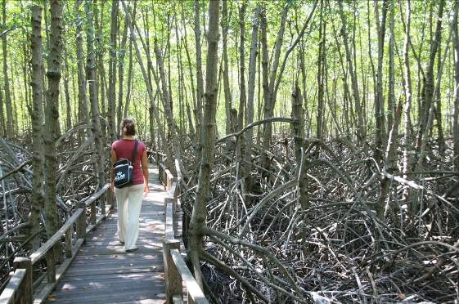
Around 15 km south of the BNK Seaside the Pranburi Forest Park is located (free entry). There is a promenade path leading visitors through the forest. If you look closely, you will see many different kinds of crabs.

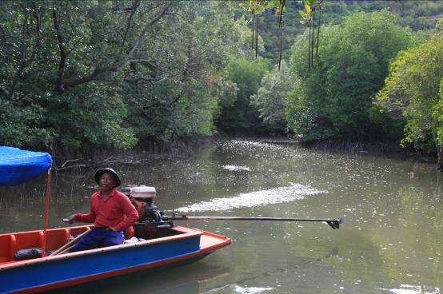
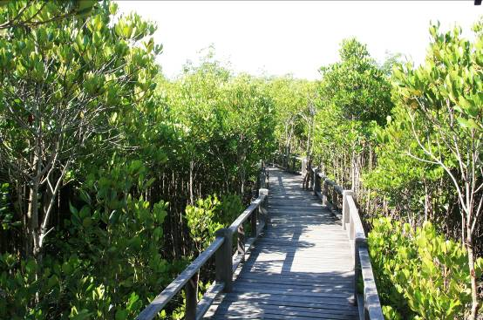
Halfway you come to the river “Mae Nam Pranburi”. Here you have the possibility to board a boat (6-8 people) that will take you on a one hour tour through the mangrove forest and the nearby harbour of “Baan Pak Naam Praan”. We can organize you a car pool or you can rent a scooter and do the tour on your own. If you would like to go for the boat tour, please inform us at the reception desk, so that we can inquire about the water level and book a boat for you (the coxswain get paid on site).

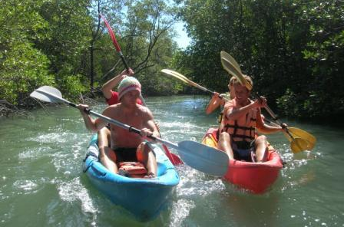

If you would to be more active we can organise a kayak tour through the mangroves (incl. mangroves trail) for you. A Kayak for two people with guide costs about 500 Baht for 2-3 hours.

