Pa-La-U Waterfall
Time: | 09.00-15.00 o’clock
Orientation price: | 1000 Baht / person incl. entry to the park
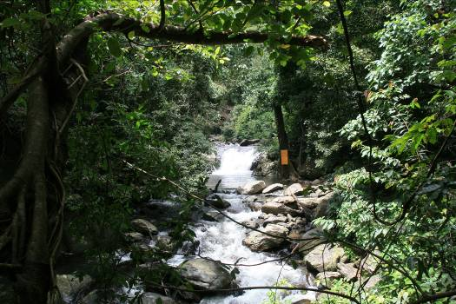
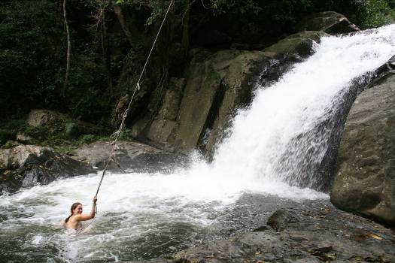
The Pa-La-U waterfall is in the jungle, 63 km west of Hua Hin, close to the Burmese frontier. The outing guides you through the region of uninhabited hills and vales. Away from asphaltic streets and near the frontier of Burma we reach the idyllic waterfall Pa-La-U, which rushes in several cascades into depth. After hiking along the waterfall and climbing across stones (good shoes are advised), an admirable refreshing bath in one of the pools (water temperature around 22-24 degrees) will be waiting for you. On this tour you experience the jungle in its natural wildness with its gigantic trees and all of the dancing butterflies.
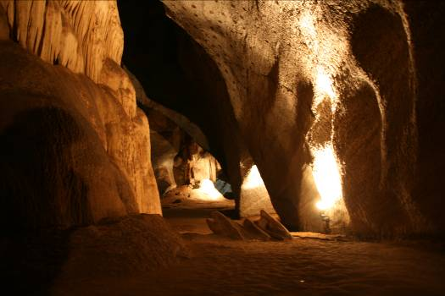
A lunch can be packed by the cook and you could have a picnic at a beautiful place or you could eat in a restaurant on the way. On the way back a visit to the Dao cave is possible. It accommodates bats and beautiful flowstones.

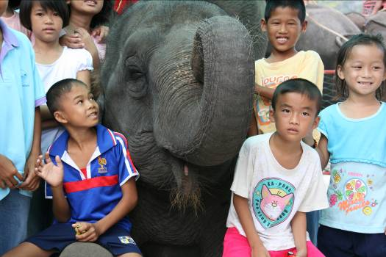
Possibility: If you have ever wanted to ride on an elephant’s back, you could have the experience on the way to the Pa-La-U at the Hutsadin Elephant’s Foundation (foundation, which takes care of sick and old elephants) for 600 Baht / person / h.

